# Introduction

A smart device is an electronic gadget that is able to connect, share and interact with its user and other smart devices. Smart devices are interactive electronic gadgets that understand simple commands sent by users and help in daily activities.

## Purpose

* To make people easy to find their comfortable devices at their reasonable prices.
* To view features and specifications of various gadgets.
* To compare different gadgets.
* To provide people with knowledge about upcoming gadgets.

## Scope

1. Admin

The admin puts the latest news on the different gadgets and also add the new devices with their details like their features, their prices along with their launch date.

1. Users

The users can simply visit the website where they can search for their devices at appropriate price along with their features and specifications.

## Limitation

1. Due to time limitation all the objectives cannot be fulfilled.
2. Some of the pages are static and only change by admin.

# References

1. [www.gadgetbytenepal.com(referenced](http://www.gadgetbytenepal.com(referenced) website)
2. images.search.google.com
3. [www.google.com/images(for](http://www.google.com/images(for) different image download purpose)
4. [www.w3schools.com(for](http://www.w3schools.com(for) different webpages reference)
5. [www.youtube.com/mmtuts](http://www.youtube.com/mmtuts)

# Description

Our website has aim to provide knowledge to the user about the gadgets and their specifications, price, about new technology, new devices and their current prices. The gadgets include of mobiles, laptops, smart watches and other smart devices.

|  |  |  |
| --- | --- | --- |
| S.N. | Name | Events |
| 1) | Login Form | An authorized member can only logged in as a member by inserting their name and password . |
| 2) | Home Page | A normal visitor can visit the website and excess all the information about gadgets. |
| 3) | Latest News | This page provides the information of the recently added Gadgets  And show on this page. |
| 4) | Mobile Price | This Page simply aims to provide all the information about mobile and their respective prices. |
| 5) | Buy Guides | This page Have some Articles and user can access all article as they want. |
| 6) | Brand Description | This page shows all the devices of only one particular Gadget. |
| 7) | Phone details | This page Only focuses on the detail information of the one particular gadget. |
| 8) | Contact | This page simply provides our information to you. |
| 9) | Dashboard | This is the page for backend world an Admin can do any changes in gadgets brands .basically CRUD is done . |

# Analysis

There are some reports can be drawn from the above relation:

1. Number of gadgets in the database.
2. Brand of the gadgets in the database.
3. Number of review posted any user.
4. Number of brand available in the databases.
5. Number of gadgets under certain brands.
6. Number of reviews under certain brands.
7. Etc.

# Solution Designed

## Relational model

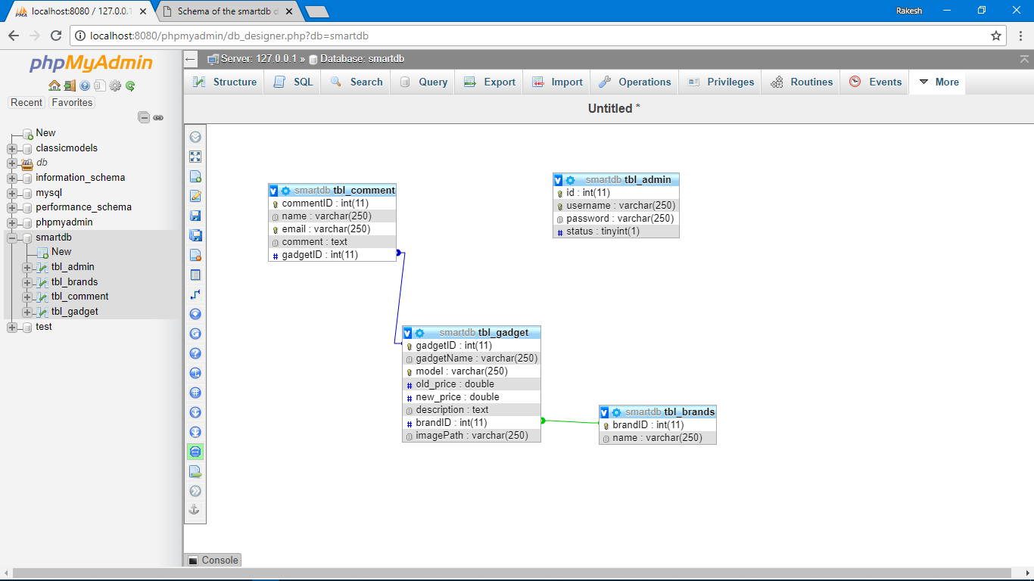

## SQL Queries

CREATE TABLE gadgets

(

gadgetID INT PRIMARY KEY AUTO INCREMENT,

name VACHAR(250),

old_price DOUBLE,

new_price DOUBLE,

model VARCHAR(250),

description TEXT,

brandID INT NOT NULL,

INDEX(brandID),

FOREIGN KEY(brandID) REFERENCES brands(brandID),

imagePath VARCHAR(250)

);

CREATE TABLE admins

(

adminID INT PRIMAY KEY AUTO INCREMENT,

username VARCHAR(250),

password VARCHAR(250),

status TINYINT(1)

);

CREATE TABLE brands

(

brandID INT PRIMARY KEY AUTO INCREMENT,

name VARCHAR(250)

);

CREATE TABLE comments

(

commentID INT PRIMARY KEY AUTO INCREMENT,

name VARCHAR(250),

email VARCHAR(250),

comment TEXT,

gadgetID INT NOT NULL,

INDEX(gadgetID),

FOREIGN KEY gadgetID REFERENCES gadgets(gadgetID)

);

# Testing

At while in testing we have tested a lot of things and we get many situations while executing the codes. Following of the situations are:

1. Admin only can open the backend work. When other than admin tries to unlock the page does not allow to enter you in.
2. To open backend pages first the admin login should have made, else it will not allow to enter.
3. The use of session and cookie allow us to remember a Admin and restrict other user in direct access of other page from URL.
4. At testing there is some error in commenting but now it is all sorted.

# Appendix

